State Differences in Light-Duty Vehicle Net Survival Rates
David L. Greene, University of Tennessee
Benjamin P. Leard, University of Tennessee
Arthur Yip, National Renewable Energy Laboratory
Ruixiao Sun, Oak Ridge National Laboratory
Ranjan Bose, Oak Ridge National Laboratory

June 2025
Abstract
Transitioning to zero-tailpipe-emission electric vehicles (EVs) is a complex and multidecadal process of systemic change. For the U.S., because of the large differences in EV adoption across states, important components of the transition include migration of used vehicles across states and their rates of survival. To assess how vehicles transition across states over time, we build an empirical model of state-level vehicle net survival, which incorporates the combined effects of vehicle migration and survival. Using state-level data on vehicle registrations during 2015-2022, we estimate how vehicle net survival depends on vehicle age and class, employment, income, and population migration.

- Introduction and Overview
Motor vehicles dominate U.S. transportation, accounting for 87% of passenger-miles traveled and 40% of freight ton-miles, with light-duty vehicles representing 87% of all highway vehicles (USDOT/BTS, 2025). As technologies such as automation and electrification transform transportation, understanding vehicle market transition dynamics and their impacts on energy, the environment, and society is crucial (Leard and Greene, 2023). Used vehicles are particularly important because they constitute approximately 95% of vehicles in use and account for the vast majority of energy use and emissions (USDOT/BTS, 2025).
In this paper, we provide a statistical analysis of state-level annual changes in registration counts of light-duty vehicles. Understanding how vehicle registrations transition over time differently across states is useful for several reasons. First, these dynamics provide insights on how state-level policies may influence the vehicle registration profile of the entire country and the geography of pollutant emissions (e.g., Newman et al., 2024). For example, California and several other states have adopted the Advanced Clean Cars Program – referred to as the ZEV program – which requires an increasing number of EVs to be sold within these so-called ZEV states. This regulation may influence the number of EVs registered in other non-ZEV states because of used EVs migrating from ZEV states to non-ZEV states. Second, understanding state-level vehicle stock changes contributes toward learning how demand for electricity and charging stations may evolve across the U.S. as electric vehicle (EV) adoption increases. As of the third quarter of 2024, all-EV plus plug-in hybrid electric vehicle (PHEV) market shares ranged from 27 percent in California, 26 percent in Colorado, and 25 percent in Washington state to 2 percent in Louisiana, West Virginia and North Dakota and 1.4 percent in Mississippi (AAI, 2025). The analysis presented below confirms that used vehicles do not stay put but migrate across states in response to economic and demographic changes and consumer preferences. Understanding the geographic dimensions of the EV transition could be useful for planning the expansion of charging infrastructure and electricity generation. Net exports of used passenger cars and light trucks from the U.S. are a small fraction (0.3%) of U.S. car and light truck registrations (U.S. Dept. of Commerce, 2025; FHWA, 2023) and are not considered in this analysis.

Migrations of used vehicles among states and differences in state vehicle survival rates have received little attendion from researchers. National scrappage and survival rates have been well studied (see, e.g., Greene and Leardb) 2024a) as have their implications for energy transition and greenhouse gas mitigation (e.g., Woody et al., 2020). The economic and environmental effects of nternational trade in used vehicles In North America (Olgun et al., 2023; Chen et al., 2018; Davis and Kahn, 2010) and worldwide have also received attention (Shi et al., 2022; Ayetor et al., 2021; Velten et al., 2020; Fuse et al., 2009; Clerides, 2008; Nieuwenhuis et al., 2007).
The remainder of this section is a brief overview of a basic theory of vehicle acquisition and disposal decisions to provide context for the analysis. In the U.S., annual changes of registrations of a certain used vehicle type j in a given state s occur because of two types of transitions: (1) movements of vehicle type j from state s to state s' or vice versa, which we denote as migration, and (2) a fraction of vehicle type j remaining in operation, which we denote as survival.
Vehicle migration
A vehicle can move across states due to a household moving. This occurs if a household registers a used vehicle type j in year t in state s, then moves in year t+1 to a different state s' and registers the vehicle in their new state. Empirically, this type of movement would imply one fewer registration of vehicle type j in state s in year t+1 and one additional registration of vehicle type j in state s' in year t+1, all else equal. This population-based net migration motivates incorporating population movements across states in our empirical model.
Vehicle transitions aross states also derive from households deciding to acquire or dispose of vehicles, where vehicle disposal means that a household removes a vehicle from their ownership. Here, we discuss and summarize simple economics behind common forms of vehicle acquisition and disposal, including the purchase and sale of used vehicles.
State and federal government agencies and private firms, including rental car companies, also make vehicle fleet purchases and disposals. However, households are part of large majority of used vehicle acquisitions and disposal decisions. Therefore, the discussion here centers around household decision making. Our empirical analysis incorporates all sources of transactions, including those involving government agencies, private firms, or households.
Each year, every household in the U.S. decides the composition of its vehicle portfolio (composed of multiple vehicles for many households), which includes all of the vehicles owned or leased by each household. Between one year and the next, households have several options, including
(1) keeping their portfolio the same,
(2) acquiring another vehicle currently not in their portfolio,
(3) returning a leased vehicle at the end of its lease to a leasing company (which then sells the vehicle),
(4) trading in a vehicle currently in their portfolio to a dealership (which then sells the vehicle),
(5) selling a vehicle currently in their portfolio to a private party,
(6) scrapping a vehicle currently in the portfolio, or
(7) a combination of (2)-(6).
Vehicle migration from one state to another occurs due to households deciding to exercise options (2)-(5) or a combination these options. Options (2)-(5) involve the transfer of vehicles across households in the used vehicle market. Currently, the used vehicle market has approximately 40 million sales annually, which is more than double the number of new light-duty vehicle annual sales (Consumer Affairs 2025, FRED 2025). Household preference for option (2) aggregates to a market demand curve for every used vehicle type and age, and household preference for options (3)-(5) aggregate to a market supply curve for every used vehicle type and age. Market equilibrium is defined by the intersection of demand and supply curves, which defines market prices and sales.
State s can experience an increase of registrations of vehicle type j if more households living in state s exercise option (2) for vehicle type j relative to those that exercise options (3)-(5) for vehicle type j. This state s positive net demand for vehicle type j would require in-migration of this vehicle type j from other states. Similarly, state s can experience a decrease of registrations of vehicle type j if fewer households living in state s exercise option (2) for vehicle type j relative to those that exercise options (3)-(5) for vehicle type j. This state s positive net supply for vehicle type j would require out-migration of this vehicle type j to other states.
How can a state have state-level excess demand or supply for a particular vehicle type? The reason has to do with household preference heterogeneity for vehicles. Household heterogeneity creates opportunities for vehicle trade across states. Consider vehicle age as a defining characteristic of vehicle type j. High-income households tend to have greater demand for new vehicles vehicles relative to low-income households. This difference leads to high-income households having net supply for used vehicles, since they replace used vehicles in their portfolio (excercising options (3), (4), or (5)) for new vehicles more frequently than low-income households. Equivalently, low-income households having net demand for used vehicles. Since household income varies across states, income-driven vehicle preference heterogeneity will cause vehicle migration, in particular migration along the vehicle age distribution. Several other forms of household preference heterogeneity may cause vehicle migration across states, which we investigate in the empirical analysis.

Vehicle survival
Another form of vehicle disposal is the decision to take a vehicle out of operation by sending it to a junk yard to be scrapped, referred to as scrappage. This happens for various reasons, such as a significant mechanical failure or getting into a traffic accident that totals the vehicle. Each year, a fraction of a particular vehicle type j is retired due to scrappage. This involves vehicles being taken out of the on-road vehicle stock between one year and the next. The remaining fraction of vehicle type j that is not scrapped is denoted as vehicle survival.
The economic theory of motor vehicle scrappage dates back at least to Cramer (1958), who derived a statistical model of vehicle longevity. Cramer’s model assumed that vehicles would be scrapped when their value depreciated to zero either due to wear and tear or a sufficiently severe accident. The two key parameters of the model were the annual depreciation rate and the probability of a severe accident. Lacking data on vehicle mileage, depreciation was assumed to be solely a function of vehicle age. Walker (1968) introduced the effect of changes in used car prices, and noted that any significant repair could make the cost of restoring a vehicle to working condition greater than its market value. Parks (1977) derived a model of survival to age $a+1$ conditional on survival to age $a$, in which vehicles were scrapped when the sum of the cost of a repair plus the vehicle’s value as scrap exceeded its price. The size of repairs was assumed to be a random variable and an increasing function of vehicle age and a decreasing function of a vehicle’s inherent durability. Subsequent studies based on variations of the economic theories of vehicle survival developed by these authors are summarized in Greene and Leard (2024a).
Empirical considerations
Ideally, we would observe a dataset that allows us to disentangle the effects of vehicle migration and survival. This would require keeping track of individual vehicle registrations, such as a database that has vehicle identification numbers (VINs) registered in a particular state in a given year. Although Department of Motor Vehicles across the country collect these data, they are proprietary and can be prohibitively expensive to obtain. In our data, we observe state-level registration counts, which do not include VINs. Therefore, we can only measure the combined effect of vehicle migration and survival. We denote the combined effect as net survival, which includes vehicles moving between states and vehicle scrappage.

rvat*=rvat+αΔvatpv(a-1)(t-1)rvat

- Data
Annual conditional vehicle survival rates are the probability that an a-year-old vehicle in year t will survive to become an a+1-year-old vehicle in year t+1. Cumulative survival rates are the probability that a new vehicle will survive to a given age a and are the product of annual conditional survival rates up to age a. State-level annual net survival rates (N_{vat}/N_{v(a-1)(t-1)}) for U.S. light-duty vehicles were provided by the National Renewable Energy Laboratory (NREL) for the years 2015/2014 to 2022/2021, by three vehicle types: passenger car, SUV and van, and pickup truck. The vehicle counts from which the net survival rates were calculated are proprietary data purchased from Experian®. The numbers of vehicles in operation were measured as of December 31 of the year. Thus, the ratio for 2021/2020 reflects changes that occurred during calendar year 2021. The survival rates are based on a total census of vehicles in operation in each state derived from state vehicle registration data. However, the specific vehicle counts used to calculate the survival rates were not available for this analysis.
Using vehicle attributes available in the original database, NREL grouped vehicles into three types: passenger cars, SUVs and vans, and pickup trucks. The vehicle attribute data are considered highly accurate since they are based on unique vehicle identification numbers (VIN). Previous analysis of vehicle scrappage and survival have shown meaningful differences in survival functions for the three vehicle types (Greene and Leard, 2024a). However, changes in the nature of the vehicles in each class over time will undoubtedly have some effect on the fit of the models to vehicles of different ages.
We call the observed state survival rates “net survival rates” because they include the effects of vehicles that are permanently retired from service (scrapped), R_{ivat}, plus the migration of vehicles into, I_{Ivat}, and out of, E_{ivat}, a state i. The data do not distinguish between differences in survival rates due to migrations of vehicles among states versus differences due to actual scrappage. The observed state survival rates, reflect only the net effect of migration and scrappage, which we refer to as net state survival rates, s_{ivat}.
$s_{iva+1t+1}=\frac{N_{ivat}-R_{ivat}+I_{ivat}-E_{ivat}}{N_{ivat}}$ (2)
State net survival rates are more variable than national survival rates because state-to-state differences in retirement rates tend to offset each other to some degree at the national level, and because except for the relatively small number of used vehicles entering and leaving the U.S., vehicle migrations among states would sum to zero. Figure 1 shows all the (unedited) state net survival rates in gray dots and the national survival rates in black dots. In addition to the greater variance of the state net survival rates, several features of the data are worth noting. There are clearly anomalies that will be discussed later in the paper. For example, the three lines of state-level dots well above the other data points from ages 1 to 30 years are the three vehicle types from the state of Tennessee in 2015. On the other hand, the lowest survival rates for vehicles greater than 30 years old, both national and state, are for the year 2021 and apparently reflect the unique effect of the COVID epidemic. Survival rates decline for the first 20-25 years, but then increase as older vehicles transition from utilitarian means of transportation to vintage collectors’ items. Finally, the variance of the state net survival rates increases with vehicle age, particularly after 20 years, while the numbers of vehicles in operation decreases.
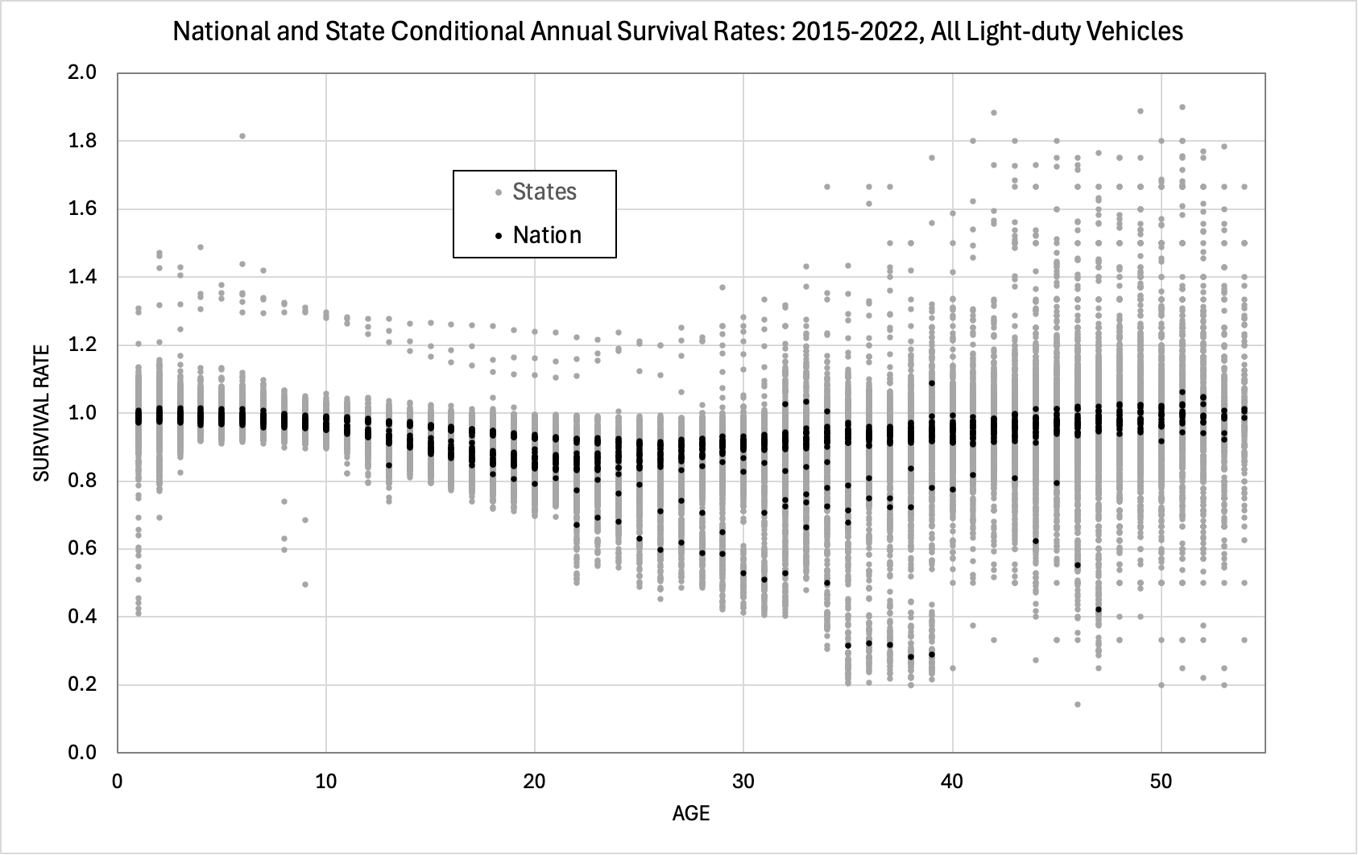
Figure 1. National and State Unedited Annual Survival Rates for All Light-duty Vehicles: 2015-2022
Our analysis comprises three phases. First, we graphed the state survival data to understand how state net survival rates differed from the national rates (the graphs can be found in Appendix B). Next, using survival rates for 2019 averaged by five age categories, we explored correlations between net survival rates by age groups and variables that might plausibly cause differences among states by means of lasso regression for variable selection analysis (Tibshirani, 1996; Stata Corp., 2025). We chose 2019 because it is the most recent year clearly unaffected by the COVID pandemic and it is in the middle of the time period of our data. Given the insights from the lasso analysis, we used OLS regression analysis on our full data set to estimate state survival functions suitable for scenario and policy analysis including continuous economic and demographic variables and fixed effects. In these estimations we attempt to to include variables that could be used to make predictions of future rates, and to represent with fixed effects state-specific factors for which forecasts are not readily available and that are likely to persist over time or to reflect unique shocks, such as the COVID-19 pandemic. Because we use only one year of our data summarized by age groups for variable selection, the usual measures of statistical siginificance retain some relevance.

- Exploratory Analysis of Factors Affecting Net Survival Rates
Graphical analysis of net survival rates revealed that state net survival rates differed in systematic and important ways from national survival rates. A sample of 6 states identified by their postal codes is shown in Figure 2, with the U.S. national rate represented by the dashed black line). Some states, especially in the South, Midwest and Mountain West have net survival rates higher than the national average for newer used vehicles. In Figure 2, Michigan, New York and California exhibit a sharp drop in net survival in year two while Texas and Alabama have sharp increases that exceed 1.0 (100%). Net survival rates exceeding 1.0 indicate net migration of vehicles into the state but net migration rates less than 1.0 reflect a combination of emigration and scrappage. All the curves decrease until 20-25 years of age and then increase, as vehicles apparently become collectors’ items. Beyond about 30 years, relatively few vehicles remain in operation and the net survival rates become noisier.
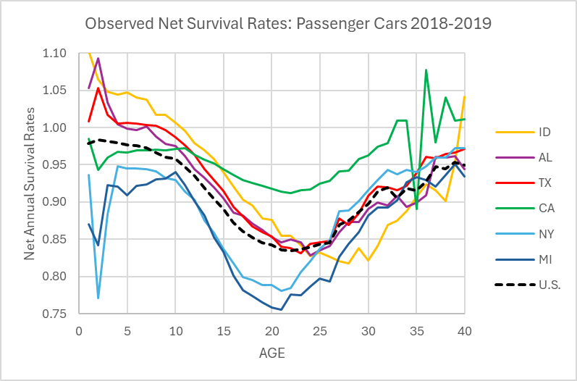
Figure 2. Observed Net Passenger Car Survival Rates for Six States and the U.S.: 2018-2019.
Vehicle survival, scrappage and migrations have been scarcely analyzed at the state level. Given the lack of prior research, we first explored the relationship of a set of potential explanatory variables to net survival rates. For this exploratory analysis we used state data for only 2018-2019 net survival rates and averaged state survival rates for five age groups: 0 to 3, 4 to 9, 10 to 15, 16 to 25 and >25 years old. These groupings were chosen to represent different aspects of the used vehicle market. At two and three years, vehicles owned by rental companies and held by individuals on leases are typically offered for sale as used vehicles. New car dealers are most active in this market segment (Cox Automotive, 2021). Non-manufacturer-franchised used car dealers are most active in the market for 4 to 9-year-old vehicles. Online retail services are active in both markets. Although all types of used vehicle sales are present at all ages, beyond nine years, the used vehicle market is a mixture of used vehicle dealers, on-line sales and person-to-person transactions. As vehicle age increases, private sales become more frequent. Cars can migrate from state to state with their owners at any age.
True scrappage (disposal) rates are very low (1% to 5%) for vehicles less than nine years old (Figure 2). Scrappage of the youngest used vehicles is typically caused by severe accident damage or other catastrophic events. Scrappage rates increase rapidly for vehicles from nine years old to 20 to 25 years of age and tend to decrease thereafter as vehicles increasingly become collectors’ items (Greene and Leard, 2024a). Therefore, we expect differences in survival rates for younger used vehicles to be strongly influenced by migrations of vehicles from one state to another, whether caused by migrations of people or by differences in the demand for new and used vehicles. Differences in survival rates for vehicles aged 10 to 25 years, when survival rates decline fastest, should also reflect differences in wear and tear due to usage and environmental factors. By dividing the statistical analysis into age groups, we hoped to identify differences in the factors affecting net survival (scrappage plus migration) as vehicles age. Scrappage rates as a function of age have also been shown to vary by vehicle types (Greene and Leard, 2024a). We divided light-duty vehicles into the same three vehicle types as that study: passenger cars, SUVs and vans, and pickup trucks.
We assembled indicators for four potential determinants of net survival rates: 1) economic, 2) demographic, 3) geographic, 4) consumer preferences and 5) vehicle wear and tear. In the economic category we included growth in disposable income, state GDP and employment, and two measures of the distribution of wealth, median household income and the share of income of the top income decile. Geographic variables were population density, fraction of population living in rural areas. Demographic variables included growth in the driving age (over 16) population and net migration. The indices of income distribution are also expected to influence preferences for new and used vehicles, and to those we added the percent of new cars that were leased rather than purchased, the percent of the population with a bachelor’s degree or higher and the percent without a high school diploma. Wear and tear was represented by average annual miles per vehicle, annual salt usage, traffic fatalities per 100,000 vehicles, and the percent of Interstate Highway miles frequently congested. The dependent variable was the average age group survival rate for each vehicle class for each state from 2018 to 2019 minus the national survival rate.
We used the Stata™ lasso software for variable selection. The lasso procedure minimizes the sum of squared errors of potential models as does OLS regression, but subject to a constraint that penalizes the weighted sum of coefficients included in the model. Variables are standardized prior to analysis. Separate analyses were run for each of the three vehicle classes. Key issues are the methods for determining the coefficient weight and total constraint value. We used the procedure’s default assumptions designed for variable selection. Determination of the parameters of the weighting constraint includes obtaining a random seed. A consequence of this is that if the data do not strongly suggest a particular set of variables, a subsequent run using the same data may produce different results. We found this to be the case for the youngest (0-3) and oldest (>25) vehicle age categories.
The results are summarized in Table 1. Shading indicates a variable was selected in both runs while no shading indicates selection in only one of the two runs. Plus signs indicate a positive relationship and minus signs negative. The two runs consistently agreed on the signs of selected variables. Growth of the driving age population includes both migration into the state and indigenous population growth, and was estimated to increase survival rates and was selected for three age categories for each vehicle type. It appears to dominate net migration which was selected only twice by both runs and only for older vehicles. Higher population density was selected only for the three middle age categories with a negative effect on survival rates. The estimation of survival models presented in the following section will show that population density’s effect changes sign when state fixed effects are included in the model. We expect economic growth to induce both migration of vehicles into a state and increased indigenous demand for vehicles. Growth in employment was selected more frequently than GDP growth, but both have a positive effect on survival rates. Other economic variables showed less consistent associations with survival rates. We hypothesized that higher lease rates would increase the supply of relatively newer vehicles for export to other states. Except for the oldest age group, lease rates were associated with lower survival rates even for older vehicles, a result generally consistent with out expectations. The fraction of the population holding a bachelor’s or advance degree was associated with reduced survival rates for older vehicles, suggesting a correlation between higher education and preference for younger vehicles. Finally, indicators of wear and tear were selected only for older age groups, and with generally negative effects on survival rates.

 | Passenger Cars |  |  |  |  | SUVs |  |  |  |  | Pickup Trucks
Variable / Age | 0-3 | 4-9 | 10-15 | 16-25 | >25 | 0-3 | 4-9 | 10-15 | 16-25 | >25 | 0-3 | 4-9 | 10-15 | 16-25 | >25
Demographic
DrivingAgePop | + | + | + |  |  | + | + | + |  |  | + | + |  | +
NetMigration |  |  |  | - | - |  |  |  | - |  |  |  |  |  | -
PopDensity |  | - |  | - |  |  | - | - | - |  |  | - | - | -
RuralPct | + |  |  |  |  | + |  | - | - |  | + |  | - | -
Economic
JobGrowth |  |  | + | + | + |  |  | + | + |  |  | + | + | + | +
GDPGrowth |  | + | + | + |  |  |  | + | + | + | + |  |  |  | +
PCDispIncGr |  |  |  | + | +
MedianIncome |  |  |  | + | + |  | - |  | + |  |  | -
Top10%Income |  |  |  |  | + |  |  |  |  | +
Market
LeaseIndex | - | - | - | - | + | - | - | - | - | + | - |  | - | -
%CollegeDeg |  | - | - | - |  |  |  | - | - |  |  |  | - | -
%NoDegree
Wear & Tear
TrafficCongest |  |  |  |  |  |  |  |  |  |  |  |  | +
FatalityRate |  |  |  | + | - |  |  |  |  | -
Miles/Vehicle |  |  |  | - | + |  |  | - | - |  |  |  | +
SaltUse |  |  | - | - | + |  |  | - | - | + |  |  | - | -
Table 1. Summary of lasso variable selection analysis of 2018-2019 state vehicle survival data.

Notes: a + sign indicates a positive effect on net survival, a – sign a negative effect. Shading, whether dark (+) or light (-) indicates both lasso runs selected the variable and both runs found the effect to have the same sign. Plus or minus signs with no shading indicate that only one of the lasso runs selected the variable.

- Specification of Models of State Net Vehicle Survival Rates
Having established that state net vehicle survival rates differ in important ways that suggest significant movements of used vehicles from state to state, and having identified variables associated with the differences in net survival rates, we now attempt to estimate statistical models that could be useful for predicting the future evolution of used vehicle fleets at the state level. To be practical, such models should be driven by factors that are predictable with acceptable errors, or that can be reasonably constructed for scenario analysis. Variables like salt use on roadways, percent of new car sales that are leases or percent of the population with a bachelors degree or higher in principle could be forecasted, but state-level forecasts are not generally available.
Variables like state population, income and employment will vary over time, and credible forecasts of these variables are available from various sources. Most of such variables either vary little and slowly over time (e.g., percent of population with a college degree), or may vary unpredictably around a mean that changes slowly over time (e.g., salt use on roadways). This suggests estimating state-level net survival functions including demographic and economic factors for which forecasts are readily available as continuous variables and representing persistent state attributes with state fixed effects and unsystematic temporal shocks, such as the COVID pandemic, with year fixed effects. In initial estimations, we found that given state and temporal fixed effects, only a small number of continuous variable could be ostensibly statistically significant (recognizing that our methodology does not support strict interpretation of significance measures as hypothesis tests).
We selected the following state net survival model formulation which we estimated separately for the three vehicle types, for vehicles more than 1 year old and less than 41 years old.
Dependent variable: Survival rate, s_{ivya}
Indexes:
i = state (Alabama to Wyoming, District of Columbia not included)
y = year pair (2015/2014 to 2022/2021)
v = vehicle type (car, SUV & van, pickup)
a = age (2 to 40)
Continuous explanatory variables:
1) natural logarithm of vehicle age (lnAge),
2) state annual growth rate of population over 16 years of age (dPop16),
3) state annual employment growth rate (dEmp),
4) state annual population density (Density)
.

Fixed effects: 1) age, 2) state, 3) year, 4) COVID2021. Fixed effect estimates are constants for each age, state and year.

Interaction: state fixed effect c_{i} with log of vehicle age, lnAge_{ivy} and COVID with selected vehicle ages. This allows the marginal effect of the state-age interaction to decrease with increasing age.
sivya=b1dGDPInciy+b2dPopiy+b3dEmpiy+b4lnMigDensityivy+ca+ci+cy+cilnAgeivy (3)
State GDP and employment data are from the U.S. Bureau of Economic Analysis (BEA, 2024). State population and land area data are from the U.S. Census Bureau (2024a, 2024b, 2024c, 2024d). Density was calculated by dividing state population by state land area. We expect income and employment growth to increase the migration of used vehicles into the state and also the demand for used vehicles and thereby reduce net scrappage and increase net survival rates. Population density had a negative sign in the lasso variable selection analysis, however that analysis was for a single year and only passenger cars and could not include state fixed effects.
We hypothesized that the effects of economic and demographic variables on net survival rates would decrease with increasing vehicle age. Used vehicle prices tend to decrease at approximately 10% per year and we supposed that the propensity to migrate with or ship a vehicle from state to state might vary with its value. The regression estimates indicated that weighting the demographic and economic variables by 0.9^^{age} did improve the fit of the model to the data.
The proposed model does not include used or new vehicle prices because a time series of state-level prices for light-duty vehicles was not available. With only seven calendar years of data and a period that included the unusual shock of the COVID-19 pandemic, it was not possible to use national used vehicle prices to accurately identify the simultaneous effects of new and used vehicle prices on survival rates. Indeed, econometric analyses of the simultaneous determination of new and used vehicle supplies and demands are scarce even at the national level (e.g. Jacobsen et al., 2021). Instead, we included year fixed effects which precludes estimating price effects based on national data.
There are undoubtedly state-specific annual shock effects but including them would require adding 350 additional fixed effects to the 96 fixed effects in Equation (2), and would create identification and multicollinearity problems with the state demographic and economic variables that also vary with state and year. Estimation of variance inflation factors (VIF) for the models summarized below showed that the formulation of Equation (2) results in acceptable VIF’s of between 1.0 and 3.0 for the demographic and economic variables and the year fixed effects, but much higher VIFs of 20 and higher for the state and age fixed effects, as would be expected, and also for population density which is highly correlated with the state fixed effects.
Inspection of residuals from the regression and the corresponding net survival data for the state of Tennessee revealed that the Tennessee data were outliers for the year pair 2015/2014 for every vehicle type and age, and were inconsistent with the state’s survival rates in other years. An indicator variable was included for that year and state in each vehicle type regression. In addition, data for the District of Columbia appeared to be erratic, frequently including extreme outliers, and we deleted DC data from the state net survival function estimations.
Although the survival rate data include vehicle ages up to at least 50 years, vehicles older than 40 years of age were excluded from the estimation of state-level survival functions for three reasons: 1) the variance of survival rates increases greatly as vehicle age increases while the number of vehicles in operation decreases greatly due to attrition (we include the older ages and outliers in the residual plots shown below); 2) vehicle scrappage rates typically increase to a maximum in the vicinity of 20 years of age and then decrease asymptotically approaching zero; 3) the results shown in Table 1 indicate that the relationships between demographic, economic and state fixed effects variables are different for vehicles older than 25 years. We hypothesize that this is due to many of the vehicles in that age group being held as collector’s items.
Finally, graphical analysis of the national and state data revealed that net survival rates for the year 2021 (from December 31, 2020, to December 31, 2021) were highly unusual for vehicles older than 20 years. Net survival rates for older vehicles dropped sharply, as illustrated by the dashed line in Figure 2. Inspection of the state data indicated that this was not a problem of missing data from some states. All states showed similar but not identical unusual decreases in net survival rates for older vehicles. The year 2021 was the height of the COVID-19 pandemic in the United States. The Center for Disease Control (2022) estimated that COVID-19 caused 460,513 deaths in that year. We speculate that, in addition to the increased deaths of vehicle owners, financial uncertainties caused by the pandemic may have led many owners of older vehicles to elect not to register or insure vehicles not essential to their travel needs. U.S. vehicle travel statistics show an unprecedented decrease of 11% in vehicle miles of travel from 2020 to 2021 (FHWA, 2023). Based on an examination of residuals, we included fixed effects for 2020 to 2021 for ages 26 to 40 for passenger cars, SUVs and vans, and 22 to 40 for pickup trucks. These coefficients reflect the average of state effects for older vehicles in 2021.
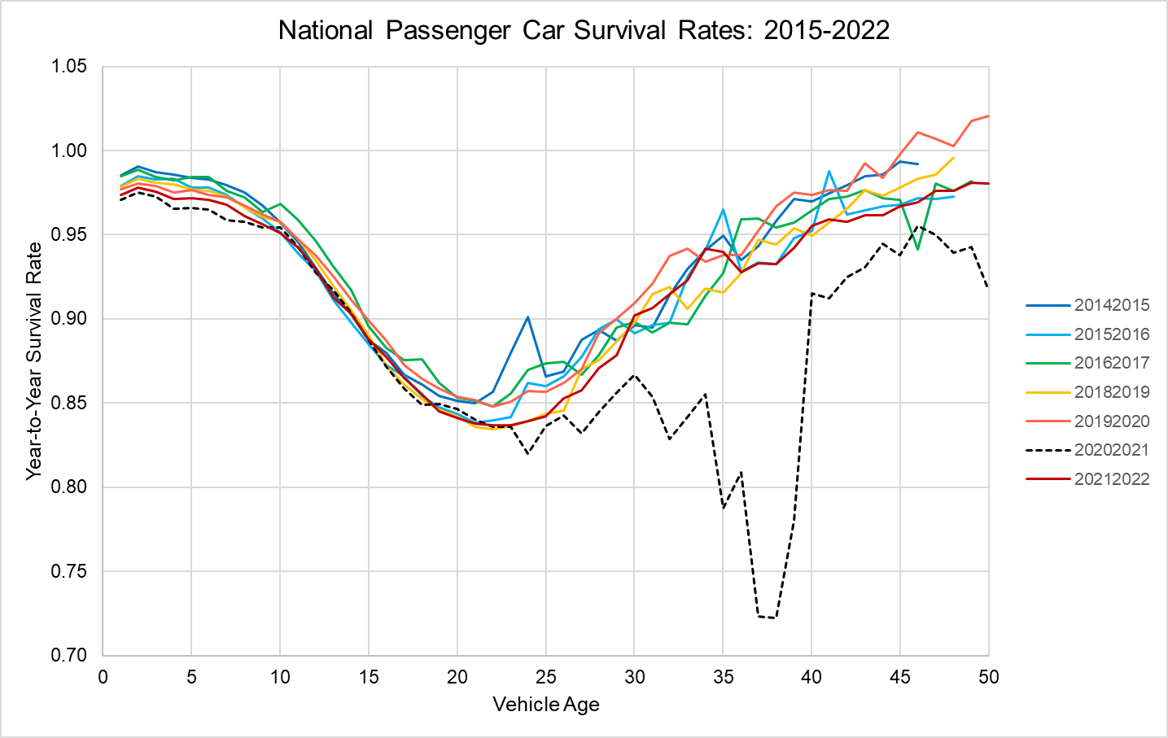
Figure 2. National Passenger Car Survival Rates: 2015-2022.

Initial estimations of the survival functions were made including all data points for the sample described above, even the data points that graphical analysis suggested were outliers (see Figures 3-5). For the final estimations, observations with residuals greater than 5 times the mean standard error in the initial estimation were dropped from the sample: 0.18 for passenger cars, 0.235 for SUVs and vans, 0.22 for pickup trucks. The relatively large values for screening outliers was chosen because of the increasing variances of residuals with vehicle age. Out of 15,600 total observations for each vehicle type, this resulted in dropping 54 observations for cars, 71 for SUVs and vans, and 29 for pickup trucks. The distribution of all residuals from the Passenger Car, SUV and Van, and Pickup Truck models, including outliers and vehicles older than 40 years, are shown in Figures 3-5.

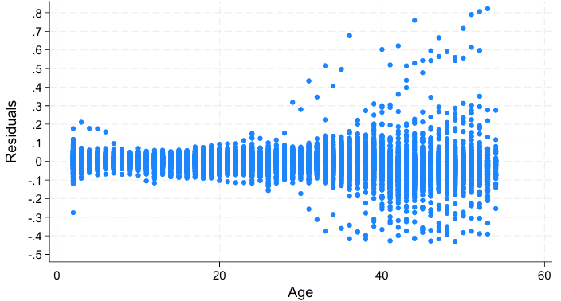
Figure 3. Residuals from the State Passenger Car Net Survival Model

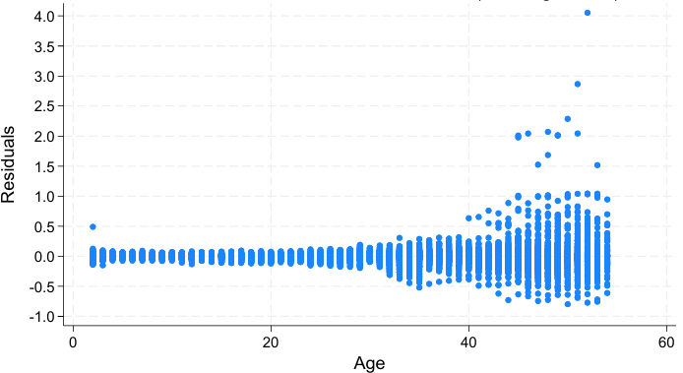
Figure 4. Residuals from the State SUV and Van Net Survival Model

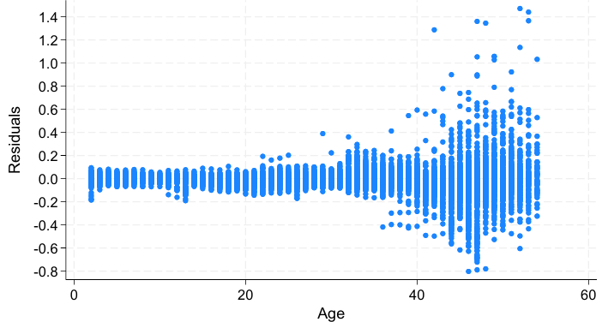
Figure 5. Residuals from the State Pickup Truck Net Survival Model

- Results
The three state net survival models for passenger cars, SUVs and vans, and pickups were estimated using the Stata™ “regress” ordinary least squares (OLS) procedure. Because the variance of residuals increases markedly with age beyond years, all regressions used the Stata™ “robust” option to account for heteroscedasticity and certain possible misspecification errors. In general, the estimated models statistically explained most of the variance in the survival data, with adjusted R² values and mean square errors of 0.82 and 0.030 respectively for passenger cars, 0.75 and 0.041 for SUVs and vans, and 0.92 and 0.035 for pickup trucks (Table 2). The residual plots above indicate that the models’ fit to the data is much better for ages up to 25-30 years than for older vehicles.
As expected, higher economic and employment growth rates, and faster population growth increased survival rates. In the SUV and van model, GDP growth replaced population growth. Density appears in all models, but with a positive sign in the presence of state fixed effects. Removing the state fixed effects changes the sign of population density, reflecting the correlation between density and state fixed effects. To the extent that the state fixed effects capture the effect of mean density, the density variable is representing total population growth. Recognizing that the significance levels are not valid for hypothesis testing, the continuous variables in all models were had estimated significant levels of 0.001 level except for the growth of population over 16 years old in the passenger car regression in which has an estimated significance level of 0.05.
The Stata “testparm” procedure calculated the combined age fixed effects to be significant at the 0.001 level, as were the state, year and COVID fixed effects and the (state)x(log(Age)) interactions as groups.⁹ The Stata “estat vif” procedure calculated variance inflation factors of 1.16 to 2.78 for the continuous variables other than density, indicating that multicollinearity is not a concern for those variables. VIF values for year and COVID fixed effects were also within acceptable levels. As would be expected, state and age fixed effects had VIF values well above 10 (typically 20 to 30), and the VIFs for the age fixed effects increased with increasing age. The vif for density also exceeded 20 due to its strong correlation with the state fixed effects. Such results are typical in regression models when there are a large number of fixed-effect coefficients, and are generally not concerning.
Coefficient estimates for Employment, Pop>16, GDP and Density plus the indicator variable for Tennessee in 2015 (TN2015) are shown in Table 2 for the Full Model and with individual fixed effects (FE) removed. In the Full Model, all four variables have p-values at the 0.001 level with the exceptions of Pop>16 (p = 0.05) in the Passenger Car model.⁹ Removing the Year FE has the greatest impact on the significance and signs of the estimates (except for TN2015) because Year represents the national impacts of changes in those variables and other variables, such as prices, that change over time. When Year FEs are included the economic and demographic variables represent state differences in those variables from the national trends. When the Year FEs are removed, the correlations of the variables with the national trends affect their coefficient estimates, resulting in reduced statistical significance and a few sign changes, for example, the statistically significant negative effect of employment in the -Year FE alternative specification. The impacts of removing the State fixed effects are smaller because the model still includes the natural log of age interacted with the State FEs, which adjust to absorb most of the effect of the State FEs. Of all the FEs, removing the Age FEs has the greatest impact on the R² values because the Age FEs describe the national tendency for net survival rates to vary with vehicle age and therefore the general shape of the net survival function. Removing the COVID FEs also has a large impact on R² because the net survival rates for older vehicles during 2021 were so different from those of other years. Removal of the COVID FEs also magnifies the coefficients of the economic variables because of COVID’s effect on the economy in 2021.
Table 2. Coefficients of the State Survival Model and the Impacts of Fixed Effects.
Variable | Full Model | Alternative Specifications
 |  | -Year FE | -State FE | -Age FE | -COVID FE
Age | X | X | X |  | X
State | X | X |  | X | X
Year | X |  | X | X | X
COVID | X | X | X | X
Passenger Cars
Employment | 0.3807*** | -0.1619*** | 0.5881*** | 0.9470*** | 0.9798***
Pop > 16 | 0.0123*** | 0.0071* | 0.0180*** | 0.0162*** | 0.0153***
Density | 0.00058*** | 0.00054*** | -0.00009*** | 0.00273*** | 0.00062***
TN2015 | 0.3187*** | 0.3261*** | 0.3230*** | 0.3199*** | 0.3192***
R² | 0.8240 | 0.8152 | 0.7937 | 0.5791 | 0.7567
RMSE | 0.03016 | 0.03091 | 0.03261 | 0.04659 | 0.03545
SUVs and Vans
Employment | 0.3705*** | -0.3098*** | 0.4396*** | 0.5289*** | 0.5626***
GDP | 0.5434*** | 0.0656 | 0.4669*** | 0.9528*** | 1.2708***
Density | 0.00108*** | 0.00102*** | -0.0001*** | 0.00268*** | 0.00129***
TN2015 | 0.3320*** | 0.3397*** | 0.3368*** | 0.3328*** | 0.3323***
R² | 0.7577 | 0.7420 | 0.7230 | 0.6352 | 0.6606
RMSE | 0.04079 | 0.04209 | 0.04355 | 0.05000 | 0.04826
Pickups
Employment | 0.5191*** | -0.1207*** | 0.7288*** | 0.5397*** | 3.7680***
Pop > 16 | 0.00578* | 0.00021 | 0.01220*** | 0.00606 | 0.02178*
Density | 0.00080*** | 0.00076*** | -0.00006*** | 0.00124*** | 0.00101***
TN2015 | 0.3012*** | 0.3012*** | 0.3055*** | 0.3013*** | 0.3035***
R² | 0.9184 | 0.9141 | 0.9073 | 0.9023 | 0.5907
RMSE | 0.03477 | 0.03565 | 0.03700 | 0.03799 | 0.07781

Note: RMSE – root mean square error; FE – fixed effects.
The resulting models reflect important differences in net survival rates across states that could be used to estimate future vehicle migrations. Estimated state net survival functions for the fifteen most populous states in 2024 are illustrated in Figures 6-8, showing the passenger car functions for the top 5, SUVs and vans for the next 5, and pickups for 11 to 15. The graphs show estimated annual net survival rates and cumulative net survival, the cumulative product of the annual rates. The cumulative curves must be interpreted with caution because they assume that the conditions existing in the year in question will continue indefinitely, which is not the case in general. While many states’ functions are similar, some important differences are evident. Some states appear to be importers of younger used vehicles (e.g., Georgia and North Carolina, Figure 7, and Tennessee and Virginia, Figure 8), with net survival rates close to or exceeding 1.0, while other states appear to be exporters with unrealistically low net survival rates for 2-10-year-old cars (e.g., New York for cars, Figure 6). The cumulative rates better illustrate tendencies to import or export vehicles. While there are some kinks in the annual rates, the effects are smoothed out considerably in the cumulative curves. Detailed examination of the state data indicates that the kinks in the estimated curves are not artifacts of the estimation but reflect the empirical data. Estimated net survival curves for 2016 for the states ranked 16-30th in population are compared in Figures 9-11. In general, states in the northeastern U.S. tend to be net vehicle exporters, while states in the south and mountain west tend to be net importers.
For most states, annual survival rates begin between 0.95 and 1.00 for 2-year-old vehicles and decline relatively slowly until about 10 years of age, after which survival rates decrease more rapidly. The decline slows approaching 20 years and reverses, increasing after about 22 years. Increasing survival rates (decreasing scrappage rates) for older vehicles were observed at the national level by Greene and Leard (2024a). The consistency in this pattern across states is partly attributable to the age fixed effects of the imposed model structure. However, the model allows state-specific effects of the logarithm of age that can shorten or lengthen the time when survival rates begin to increase.
Cumulative net survival rates are the cumulative product from 2, to 40 years of annual survival rates, assuming the conditions in 2022 or 2016 continued. In that sense, they are hypothetical because when conditions change in 2023, annual net survival will change, altering the cumulative rates in that year. The cumulative curves represent what would happen if the given year’s rates persisted for 40 years, but in reality, they will change. Net survival rates even a small amount greater than 1.0, if they persist, can imply a large immigration of newer used vehicles into a state. For example, note SUVs and vans in Georgia and North Carolina in Figure 7 and pickups in Washington, Tennessee and Virginia in Figure 8. Similar patterns can be seen for South Carolina, Alabama and Colorado in Figure 10 and Kentucky, Oregon and Utah in Figure 11.

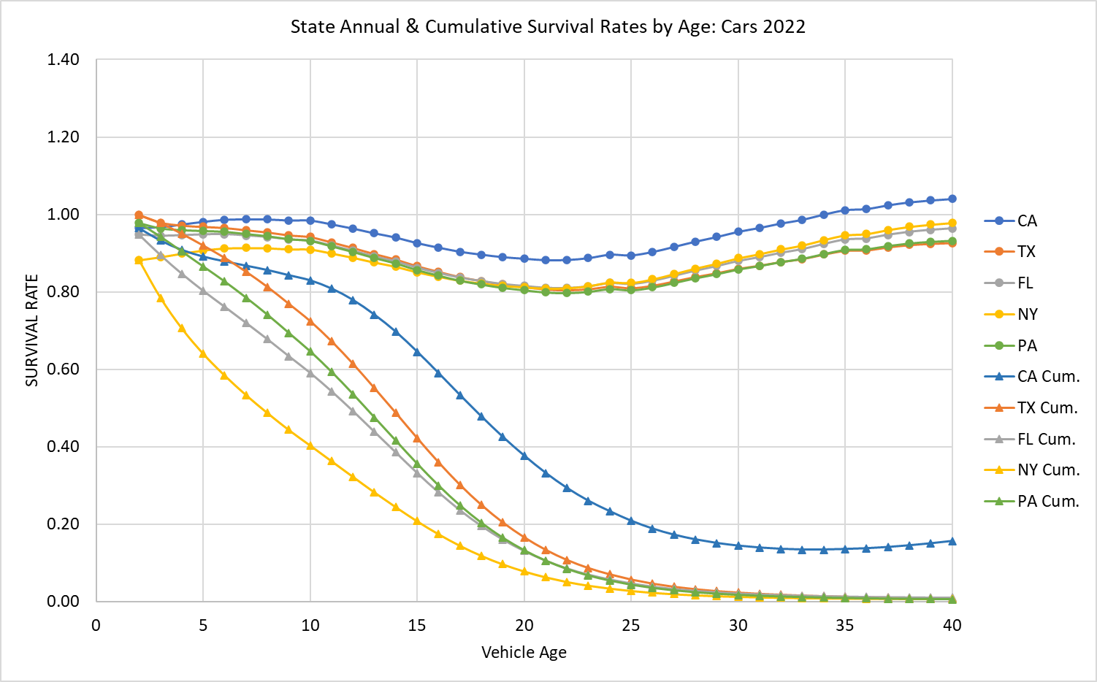
Figure 6. Predicted Annual and Cumulative Survival Rates by Age for Five States: Cars 2022

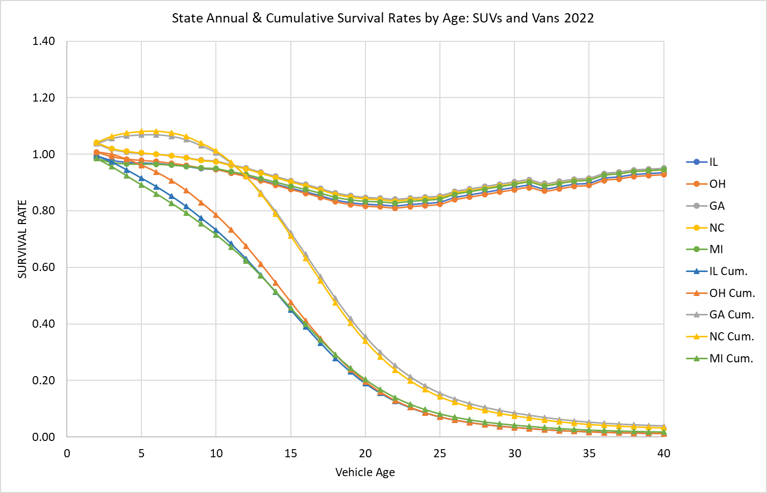
Figure 7. Predicted Annual and Cumulative Net Survival Rates by Age for Five States: SUVs and Vans 2022

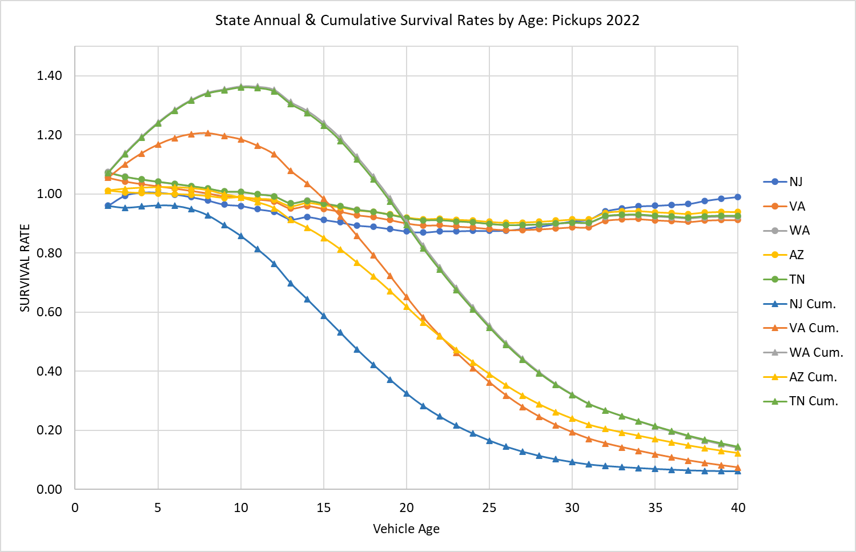
Figure 8. Predicted Annual and Cumulative Net Survival Rates by Age for Five States: Pickups 2022

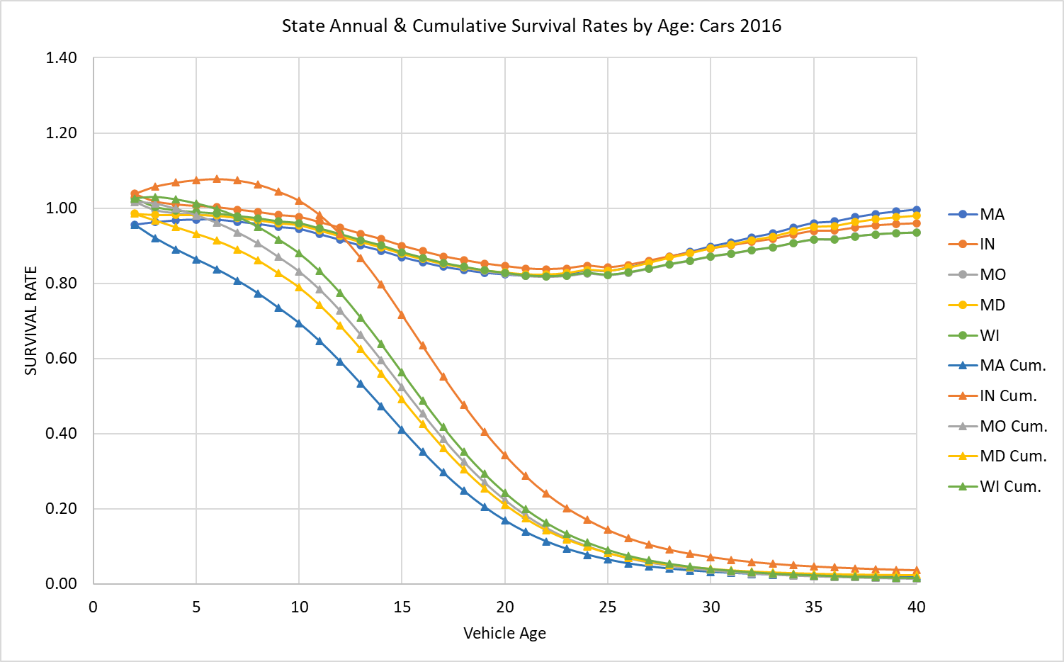
Figure 9. Predicted Annual and Cumulative Net Survival Rates by Age for Five States: Passenger Cars 2016
The sunbelt states have seen rapid population growth since 2010. From 2010 to 2020, the populations of the Northeast and Midwest grew by 4.1% and 3.1%, respectively, while those of the West and South grew by 19.2% and 10.2%, respectively (U.S. Census, 2024). This continues a decades long pattern of migration that was interrupted by the COVID pandemic. Estimates for 2018 show New York and New Jersey as donor states for pickups with unusually low net survival rates, and Tennessee, South Carolina and Alabama as receivers with unusually high net survival rates.

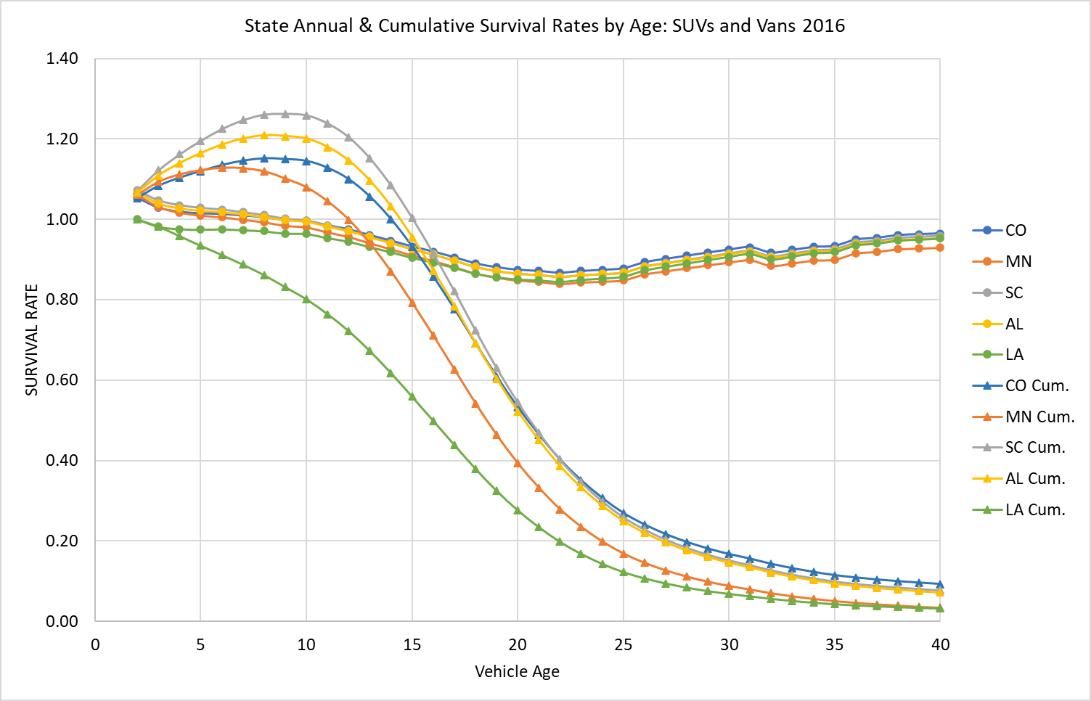
Figure 10. Predicted Annual and Cumulative Net Survival Rates by Age for Five States: SUVs and Vans 2016

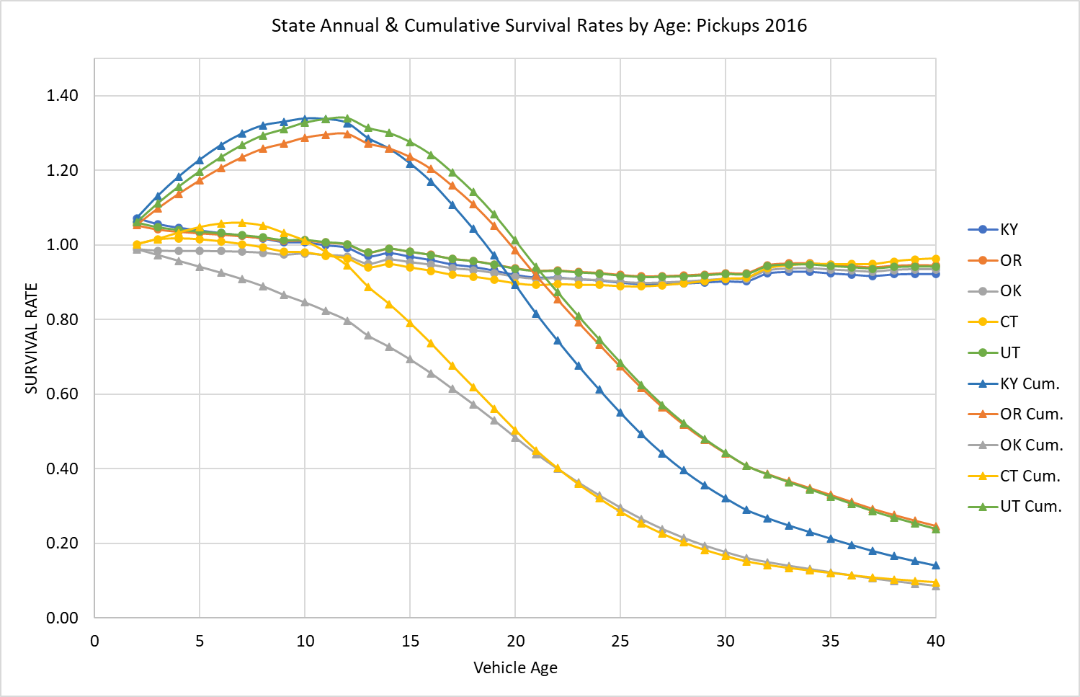
Figure 11. Predicted Annual and Cumulative Net Survival Rates by Age for Five States: Pickups 2016
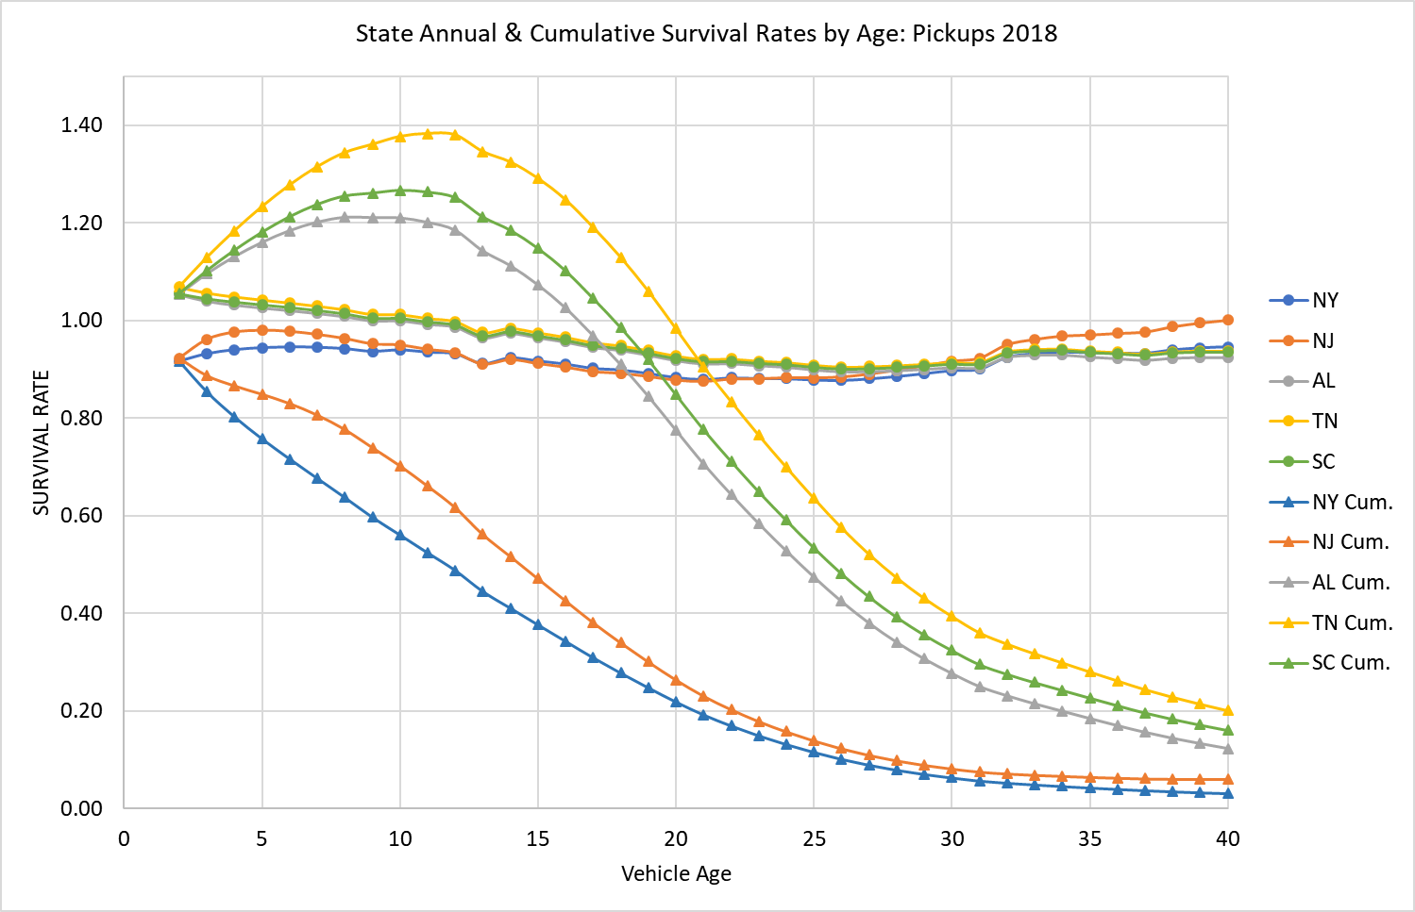
Figure 12. Apparent Import and Export States for Pickup Trucks: 2018.
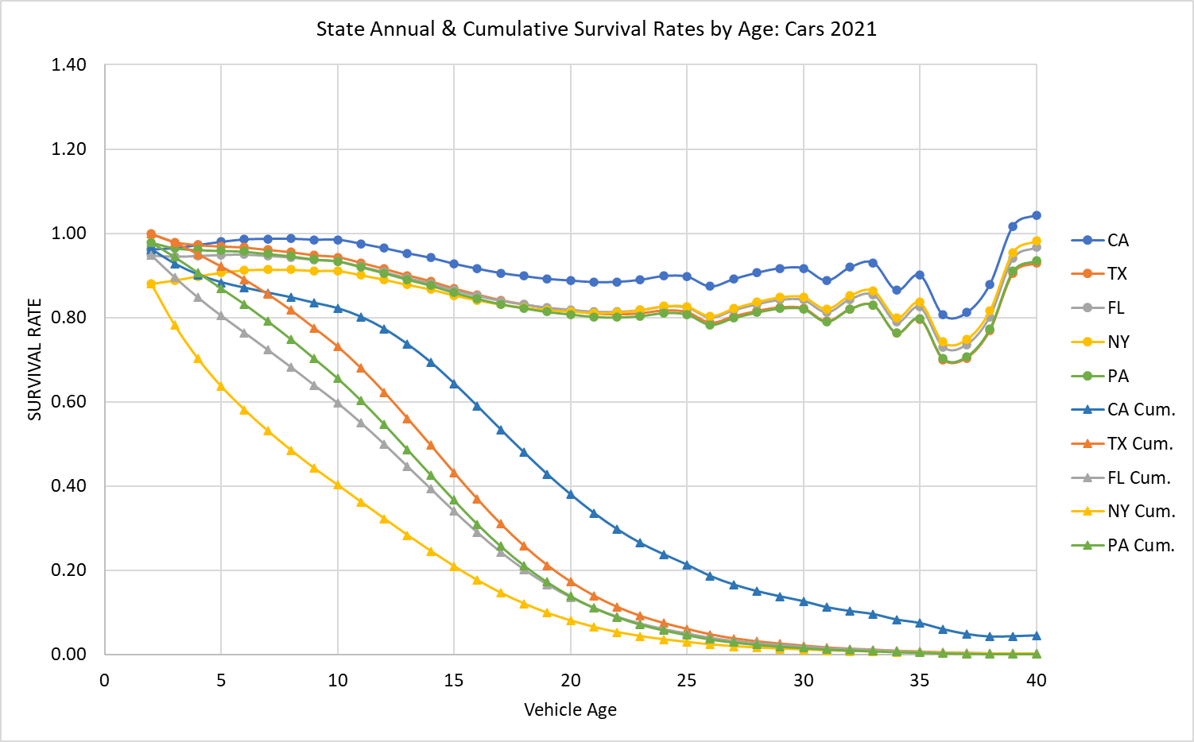
Figure 13. Predicted Annual and Cumulative Net Survival Rates of Passenger Cars at the Hieght of the COVID Pandemic: 2021

Figures 14-16 show estimated net survival curves for the same states as Figures 6-8. but for the peak pandemic year of 2021. The unprecedented changes caused by the global pandemic had a much smaller effect on the net survival rates of older passenger cars than on SUVs, vans and pickups. The drastic effects of the pandemic on older pickups may be due to their higher use in commerce.
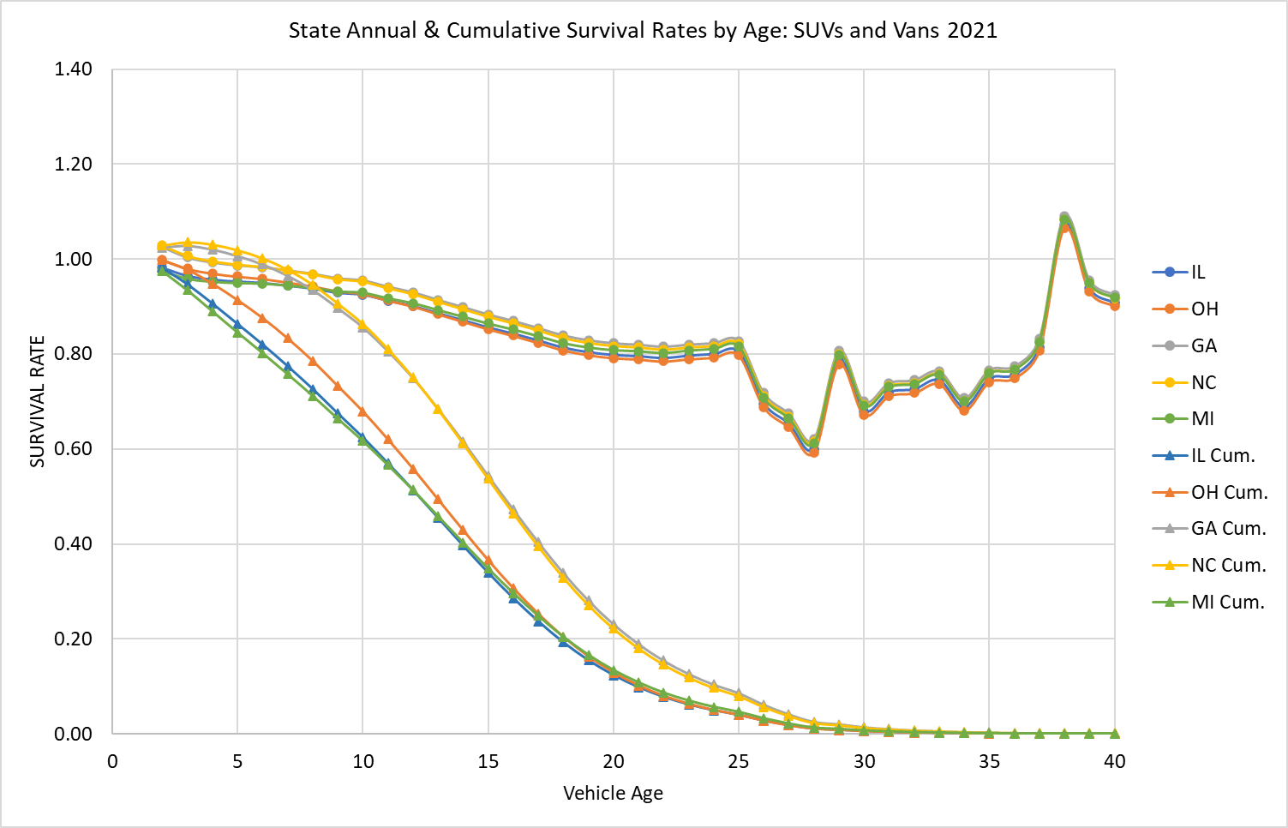
Figure 13. Predicted Annual and Cumulative Net Survival Rates of SUVs and Vans at the Hieght of the COVID Pandemic: 2021
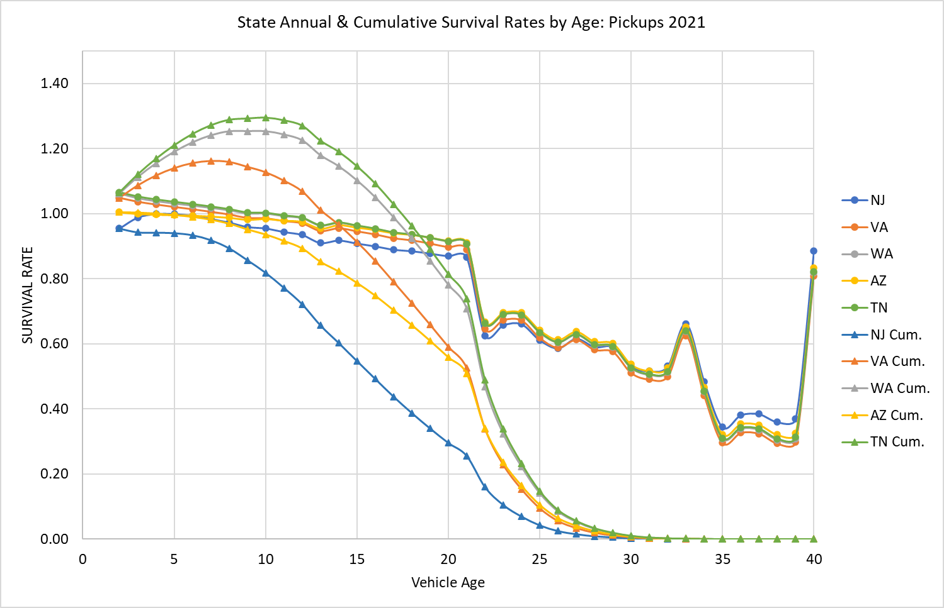
Figure 14. Predicted Annual and Cumulative Net Survival Rates of Pickups at the Hieght of the COVID Pandemic: 2021

- Discussion:

- Limitations
The chief limitation of our analysis is that the data available to us do not allow us to distinguish between flows of used vehicles from one state to another and differences in scrappage rates. Instead we observe only net survival rates. If the patterns of flows are relatively stable over time, or if population and employment variables satisfactorily capture changes over time, the existing model formulation should produce reasonably accurate estimates of future used vehicle migrations. However, it may also be desirable to impose some restrictions on the projected state flows to ensure that used vehicles are not newly created or excessively destroyed. For example, neglecting net exports of used vehicles from the U.S., the sum of the total counts of state differences from national scrappage by vehicle type and year, must sum to zero. However, whether it is useful or important to constrain state net vehicle scrappage with a national function is not clear at present.
Although our lasso analysis indicated that many factors affect state net survival rates, only a few could be included in our statistical models of net survival. This is chiefly due to the inclusion of many fixed effects that better represented state attributes that change slowly over time, but it is also likely due to correlations among the economic and demographic variables. Although we tried using factor analysis of those variables, the resulting factors did not appear to us to have meaningful interpretations.
As noted above, our method does not fully support the use of measures of statistical significance for hypothesis testing in out final models. In part, this is because we used one year of summarized data in our lasso analysis. But it is also because we additionally eliminated variables with low p-values and substituted GDP for driving age population growth in the SUV model because the latter had a high p-value.
The fact that the state survival models contain numerous fixed effects limits their usefulness for long-run forecasting. The state and age fixed effects represent the average fixed effects over the period on which the model was estimated (2016-2022). This is also true of state and log of age interaction coefficients, as well as the coefficients of employment, price and state migrations. The COVID effectsshould be omitted, assuming a future pandemic is not being forecasted. The year fixed effects, however, represent the impacts of temporal factors not fully reflected in the included variables. Because of this, it would not necessarily be best to use the year effect of the final year, 2022, although that is a plausible assumption. One alternative would be to average the year fixed effects, omitting the COVID year of 2021.
Although the inclusion of state population density by year improved the fit of the model to the data incomparison to models that excluded it in favor of, e.g., income or population growth, density’s vif and the testi run omitting state effects indicate that it is strongly correlated with the state fixed effects. Moreover, we do not have an obvious explanation of why population density should positively affect net vehicle survival. Perhaps it reflects reduced vehicle miles, or a greater propensity of urban and suburban consumers to prefer newer vehicles. Regardless, because of the correlation with state fixed effects, the models should not be used to predict the effects of large changes in population density.

rivat*=rivat1+Δivat+δivatpivatα= rivat+αΔivat+δivatpivatrivat

The research completed to date indicates that it is possible to construct useful state survival and scrappage models for the three vehicle types. The state-level net survival models indicate that, even though they are not directly observed in our data, there are substantial movements of used vehicles, especially newer used vehicles from state to state. This is because many states have survival rates greater than 1.0 for vehicles from 2 to 5 or even 10 years of age. Some vehicles move with owners who migrate to another state while others area shipped to other states and sold to new owners. Although the net survival effects in a single year are relatively small, e.g. single digit percents, the cumulative effect over five or ten years can be substantial. The models also suggest that state scrappage rates likely differ, especially for older vehicles, due to usage and wear and tear..
Movements of used vehicles are likely to be important to understanding transitions to electric vehicles because of the large differences in market shares across states, and because migrations of used EVs will affect the rate of innovation diffusion and the geography of electricity demand.Effectively modeling the transition to zero emission vehicles will also require separately tracking all-electric, PHEV, and perhaps fuel cell and hybrid electric vehicles. Because mass-produced plug-in vehicles are a relatively recent phenomenon and their technology, product offerings, and supporting infrastructure have rapidly evolving, it is not possible to empirically estimate complete survival functions for them at this time. .

Differences in vehicle scrappage and survival, and the migrations of used vehicles from state-to-state is an aspect of the vehicle market that has received little attention. This study has shown that differences in state vehicle survival rates can be modeled statistically, that there are substantial differences across state due to immigration and emigration of vehicles and differences in state scrappage rates. Additional research, using more detailed data is needed to distinguish vehicle migrations from scrappage, as well as to distinguish between electric and internal combustion vehicles.

- References

- Alberini, A., M. Bareit, M. Filippini, A.L. Martinez-Cruz, 2018. “The impact of emissions-based taxes on the retirement of used and inefficient vehicles: The case of Switzerland,” Journal of Environmental Economics and Management, 88: 234-258.
- Alliance for Automotive Innovation (AAI), 2025. “Get Connected: Electric Vehicle Quarterly Report,” Third Quarter 2024. https://www.autosinnovate.org/posts/papers-reports/get-connected-q3-2024.
- Ayetor, G., I. Mbonegaba. M. Sackey, P. Andoh, 2021. “Vehicle regulations in Africa: Impact on used vehicle import and new vehicle sales”. Transportation Research Interdisciplinary Perspectives, 10. https://doi.org/10.1016/j.trip.2021.100384 .
- Bento, A., K. Roth and Y. Zuo, 2018. “Vehicle Lifetime and Scrappage Behavior: Trends in the U.S. Car Market,” The Energy Journal, 39(1): 159-183.
https://www.researchgate.net/publication/322177636_Vehicle_Lifetime_Trends_and_Scrappage_Behavior_in_the_US_Used_Car_Market
- Burra, L., M. Kasawaneh and C. Cirillo, 2024. “Impact of charging infrastructure on electric vehicle adoption: A synthetic population approach,” Travel Behaviour and Society, 37 (2024). https://doi.org/10.1016/j.tbs.2024.100834.
- Chen, L., B. Garcia-Medina, and R. Wan, 2019. “Trade liberalization, consumption shifting and pollution: Evidence from Mexico's used vehicle imports”. Review of International Economics, 27:1591-1608. https://doi.org/10.1111/roie.12436 .
- Clerides, S., 2008. “Gains from trade in used goods: Evidence from automobiles”. Journal of International Economics, 76(2):322-336. https://doi.org/10.1016/j.jinteco.2008.07.009 .
- Consumer Affairs, 2025. https://www.consumeraffairs.com/automotive/used-car-statistics.html.
- Cox Automotive, 2021. “Commentary: Independent Dealers are Poised to Thrive as Driving Force in Recovery,” https://www.coxautoinc.com/market-insights/commentary-independent-dealers-are-poised-to-thrive-as-driving-force-in-recovery/ .
- Cramer, J., 1958. “The Depreciation and Mortality of Motor-Cars,” Royal Statistical Society. Journal. Series A: General, 121(1): 18–46. https://doi.org/10.2307/2342989.
- Davis, L. and M. Kahn, 2010. “International Trade in Used Vehicles: The Environmental Consequences of NAFTA”, American Economic Journal: Economic Policy, 2(4):58-82.
- Federal Highway Administration (FHWA), 2023. Traffic Volume Trends December 2023. https://www.fhwa.dot.gov/policyinformation/travel_monitoring/23dectvt/23dectvt.pdf.
- Fuse, M., H. Kosaka and S. Kashima, 2009. “Estimation of world trade for used automobiles”. Journal of Material Cycles and Waste Management, 11:348-357. https://doi.org/10.1007/s10163-009-0263-3 .
- FRED, 2025. https://fred.stlouisfed.org/series/ALTSALES
- Greene, D.L. and B.P. Leard, 2024a. “Trends in scrappage and survival of U.S. light-duty vehicles,” Transportation Research A: Policy and Practice, 180: https://doi.org/10.1016/j.tra.2024.103982.
- Greene, D.L. and B.P. Leard, 2024b. “MA3T Used Vehicle Model Documentation,” unpublished manuscript of March 27, 2024, available from the authors. Baker School of Public Policy and Public Affairs, University of Tennessee, Knoxville, TN.
- Greene, D.L. and B.P. Leard, 2024c. “Enhancements to the ORNL MA3T Used Vehicle Model to Enable Analysis of Taxes, Subsidies and Other Policies Directed at Used Vehicles,” Unpublished project report, available from the authors, Baker School of Public Policy and Public Affairs, University of Tennessee, Knoxville, TN.
- Greene, D., E. Kontou, B. Borlaug, A. Brooker, M. Muratori, 2020. “Public charging infrastructure for electric vehicles: What is it worth?,” Transportation Research D, vol. 78: 102182, https://doi.org/10.1016/j.trd.2019.11.011.
- Greenspan, A. and D. Cohen, 1999. “Motor Vehicle Stocks, Scrappage and Sales,” Review of Economics and Statistics, 81(3): 369-383.
https://www.jstor.org/stable/2646761?seq=1
- Hawley, R.E., 2024. “Car depreciation: What it is and how it works,” Bankrate. https://www.bankrate.com/insurance/car/understanding-car-depreciation/.
- Jacobsen, M., R. Beach, C. Cowell, and J. Fletcher, 2021. “The Effects of New-Vehicle Price Changes on New- and Used-Vehicle Markets and Scrappage,” EPA-420-R-21-019, U.S. Environmental Protection Agency, Office of Transportation and Air Quality, https://cfpub.epa.gov/si/si_public_record_Report.cfm?dirEntryId=352754&Lab=OTAQ .
- Jacobsen, M.R. and A.A. van Bentham, 2015. “Vehicle Scrappage and Gasoline Policy,” American Economic Review, 105(3): 1312-1338.
- Junk Car Reaper, 2024. “Average Vehicle Lifespan in the USA: A State-by-State Analysis”, internet article accessed at https://www.junkcarreaper.com/guides/vehicle-lifespans/ on 6/11/2025.

- Leard, B. and D. Greene, 2023. “Coordinating the Electric Vehicle Transition and Electricity Grid Decarbonization in the U.S. is Not Essential to Achieving Substantial Long-Term Carbon Dioxide Emissions Reductions,” Environmental Research Letters, 18(7), 074035. https://iopscience.iop.org/article/10.1088/1748-9326/acdd85.
- Lin, Z., D. Greene and J. Ward, 2025. User Guide of the ORNL MA3T Model (V20130729). Available at teem.ornl.gov/ma3t.shtml.
- Newman, S., K. Schulte, M. Morellini, C. Rahal and D. Leasure, 2024. “Offshoring emissions through used vehicle exports”. nature climate change, 14:238-241. https://doi.org/10.1038/s41558-024-01943-1
- Nieuwenhusi, P., A. Beresford and P. Choi, 2007. “Shipping Air? Tracking and Forecasting the Global Shipments of New and Used Cars”. IV(3): 17-36. ISSN: 1697-4840.
- Olguín, F., G. Iskakov and A. Kendall, 2023. “US-Mexico second-hand electric vehicle trade: Battery circularity and end-of-life policy implications”, Transportation Research D: Transport and Environment, 125. https://doi.org/10.1016/j.trd.2023.103934 .
- Parks, R., 1977. “Determinants of Scrapping Rates for Postwar Vintage Automobiles,” Econometrica, 45(5), 1099-1115. https://www.jstor.org/stable/1914061 .
- Shi, Y., T. Arthanari, V. Venkatesh, S. Islam and V. Mani, 2022. “Usedvehicle global supply chains: perspectives on a direct-import model”. Supply Chain Management: An International Journal. 27(3): 333–347. https://doi.org/10.1108/SCM-06-2020-0238 .

- Stata Corp., 2025. Stata 19 Lasso Reference Manual, College Station Texas, Stata Press.
- Tibshirani, R., 1996. “Regression Shrinkage and Selection Via the Lasso”, Journal of the Royal Statistical Society: Series B (Methodological), 58(1):267–288, https://doi.org/10.1111/j.2517-6161.1996.tb02080.x
- U.S. Census Bureau, 2024a. State-to-State Migration Flows. “Table 1. State-to-State Migration Flows¹: 2023 American Community Survey 1-Year Estimates” by year, 11/2024. https://www.census.gov/data/tables/time-series/demo/geographic-mobility/state-to-state-migration.html.
- U.S. Census Bureau, 2024b. “State Population Totals and Components of Change: 2020-2023,” and “Annual Estimates of the Resident Population for the United States, Regions, States, the District of Columbia, and Puerto Rico: April 1, 2010, to July 1, 2019; April 1, 2020; and July 1, 2020.” https://www.census.gov/data/tables/time-series/demo/popest/2020s-state-total.html.
- U.S. Census Bureau, 2024c. “Historical Population Change Data (1910-2020).” https://www.census.gov/data/tables/time-series/dec/popchange-data-text.html.
- U.S. Census Bureau, 2024d. State Area Measurements and Internal Point Coordinates 2010, accessed at https://www.census.gov/geographies/reference-files/2010/geo/state-area.html .
- U.S. Bureau of Economic Analysis (BEA), 2024. Regional Data: GDP and Personal Income, “SASUMMARY State annual summary statistics: personal income, GDP, consumer spending, price indexes, and employment,” https://apps.bea.gov/itable/?ReqID=70&step=1#eyJhcHBpZCI6NzAsInN0ZXBzIjpbMSwyOSwyNSwzMV0sImRhdGEiOltbIlRhYmxlSWQiLCI2MDAiXSxbIk1ham9yX0FyZWEiLCIwIl1dfQ==.
- U.S. Department of Commerce, Bureau of the Census, Foreign Trade Division, TPIS Database USHS EXPORTS, Revised Statistics for 1989-2023, Unrevised Statistics for 2024. https://trade.gov/data-visualization/used-vehicle-trade-data-visualization .
- U.S. Department of Transportation, Bureau of Transportation Statistics, National Transportation Statistics 2025. https://www.bts.gov/topics/national-transportation-statistics, tables 1-11, 1-40 and 1-50.
- Velten, E., C. Brauer, and J.-E. Thie, 2020. “Used vehicle trade and fleet composition in Europe”. Final report of the project “Used vehicle trade and fleet composition in Europe” on behalf of the EEA. Ecologic Institute and Fraunhofer Institute for Systems and Innovation Research ISI: Berlin, Karlsruhe.
- Walker, F., 1968. “Determinants of Auto Scrappage,” Review of Economics and Statistics, 50(4): 503- 506.

Appendix A. State Vehicle Survival Model Estimation Results
Passenger Cars

SUVs and Vans

Pickups

Appendix B. Graphs of State-level Cumulative Survival Rates by Vehicle Type: 2018 to 2019
The following graphs were created by Arthur Yip of the National Renewable Energy Laboratory to determine whether state scrappage rates varied across states and differed from national rates. The graphs reveal some striking differences. Some consistency is evident by state across the three vehicle types. States like Idaho, that have unusually high survival rates for newer used passenger cars, also have high survival rates for new SUVs and pickup trucks. The graphs provided the first evidence of systematic differences in survival rates among states.
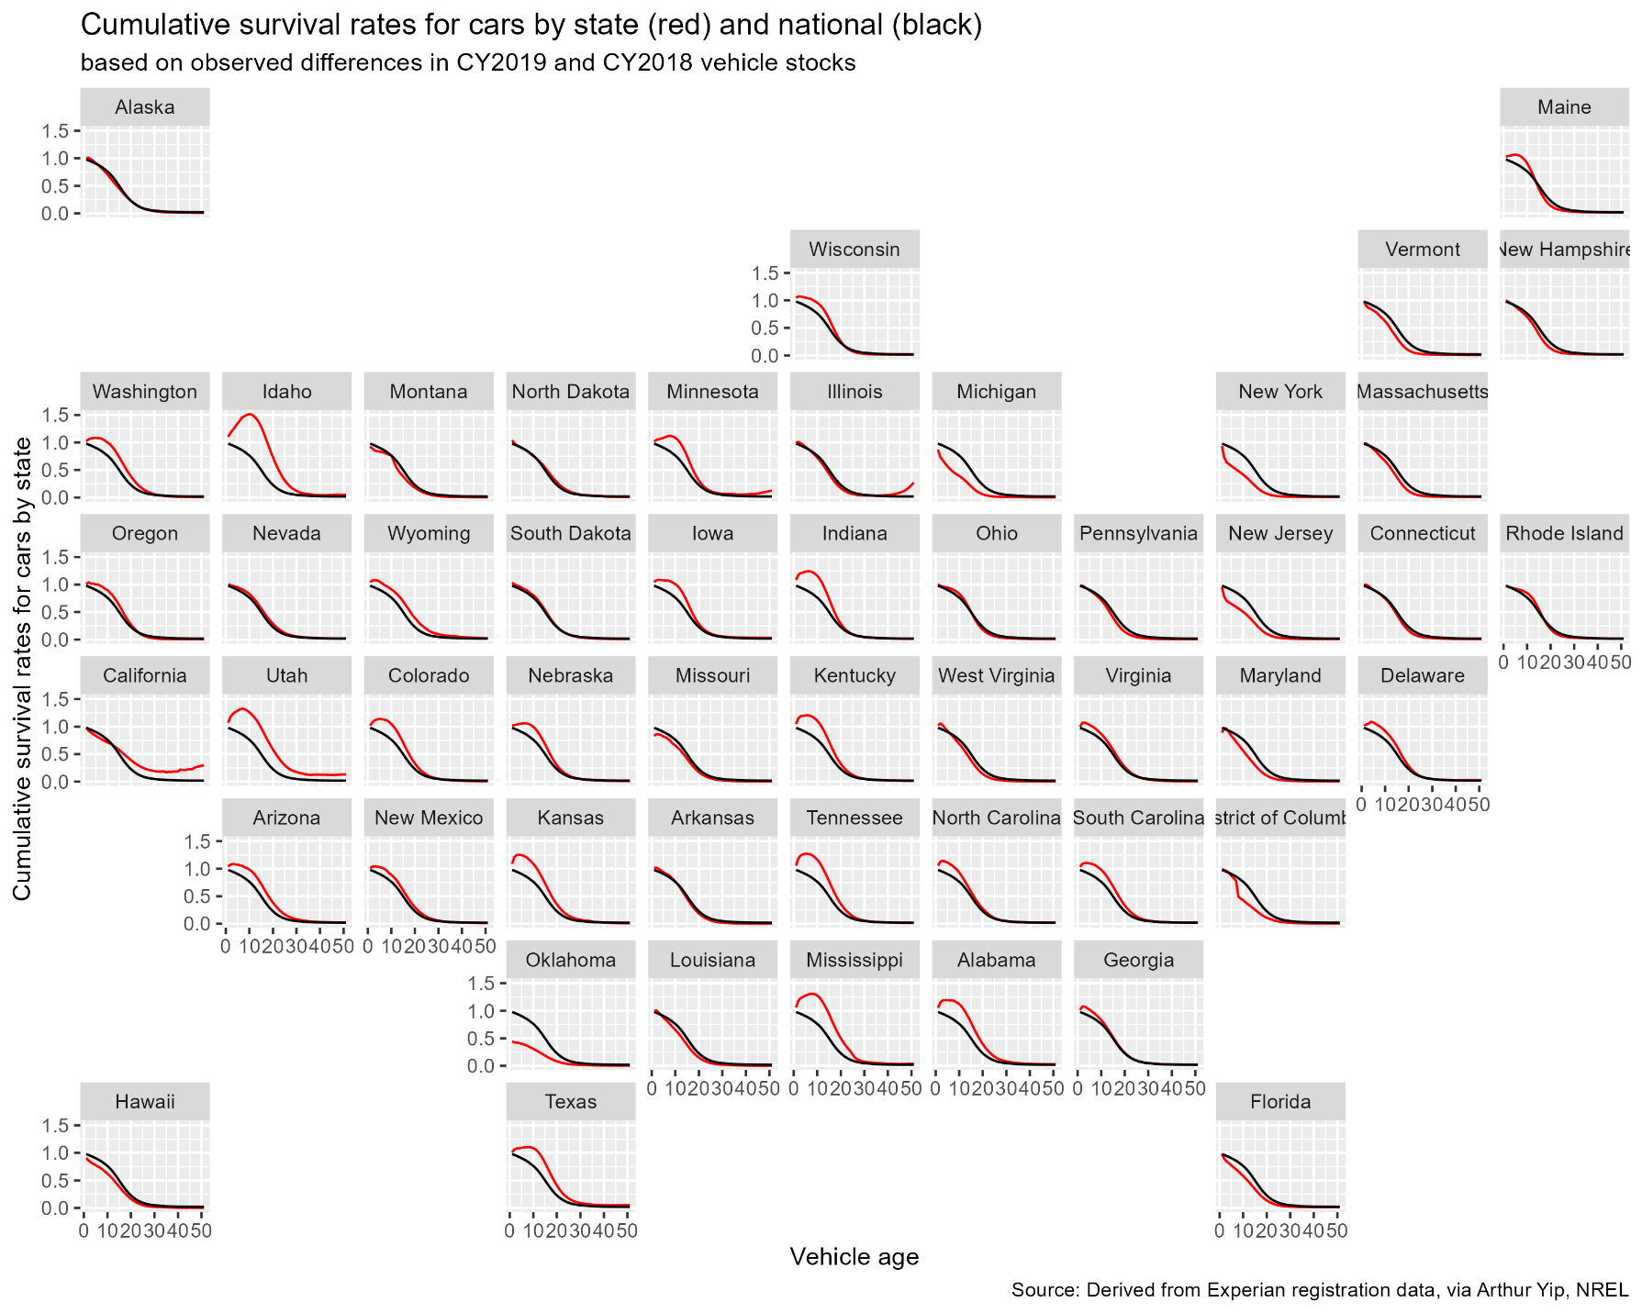
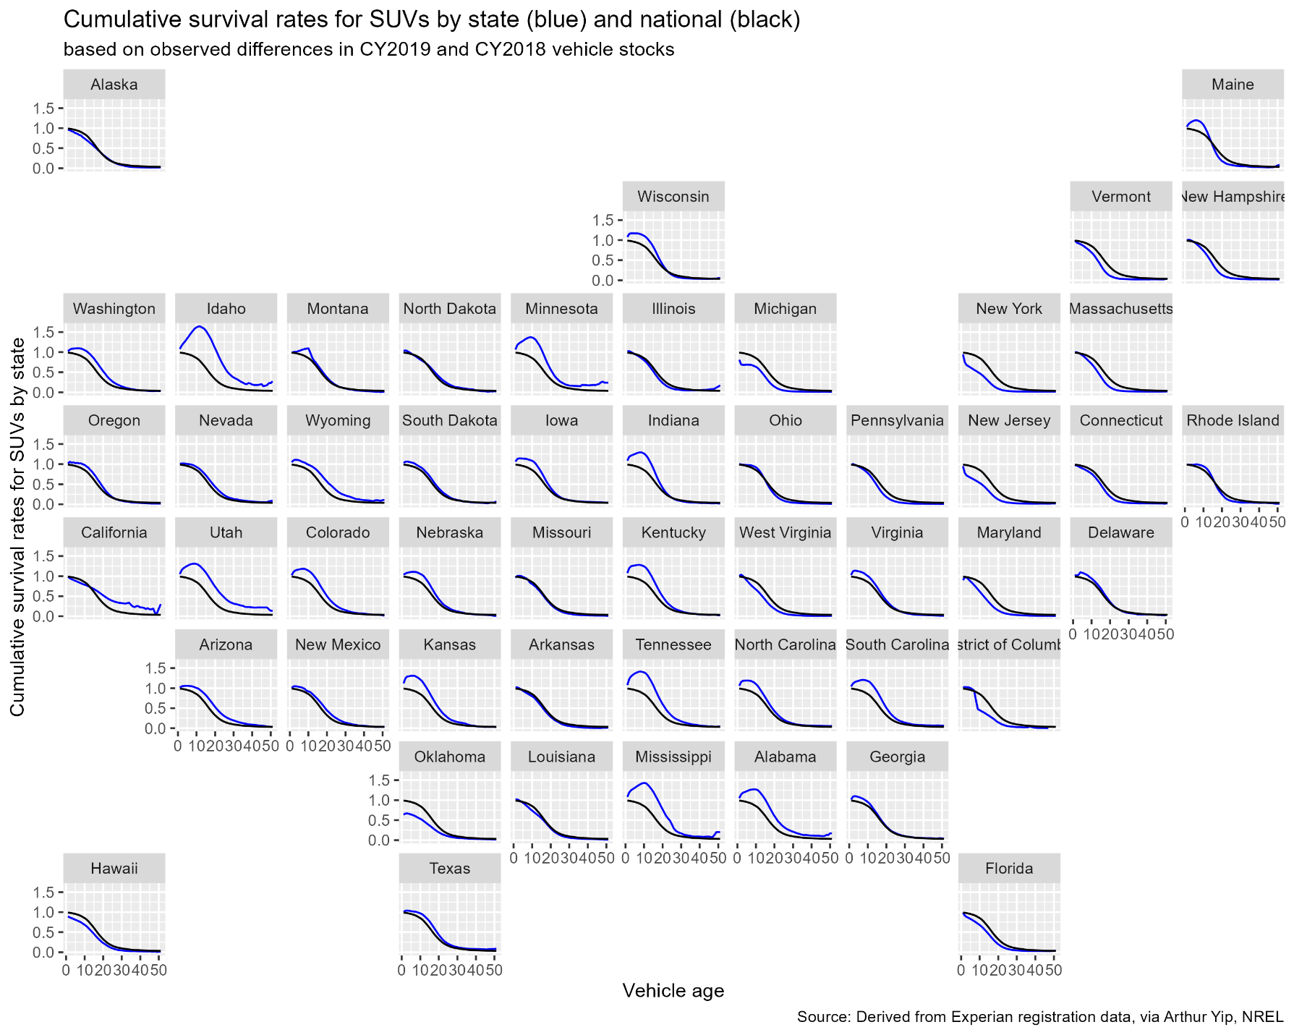
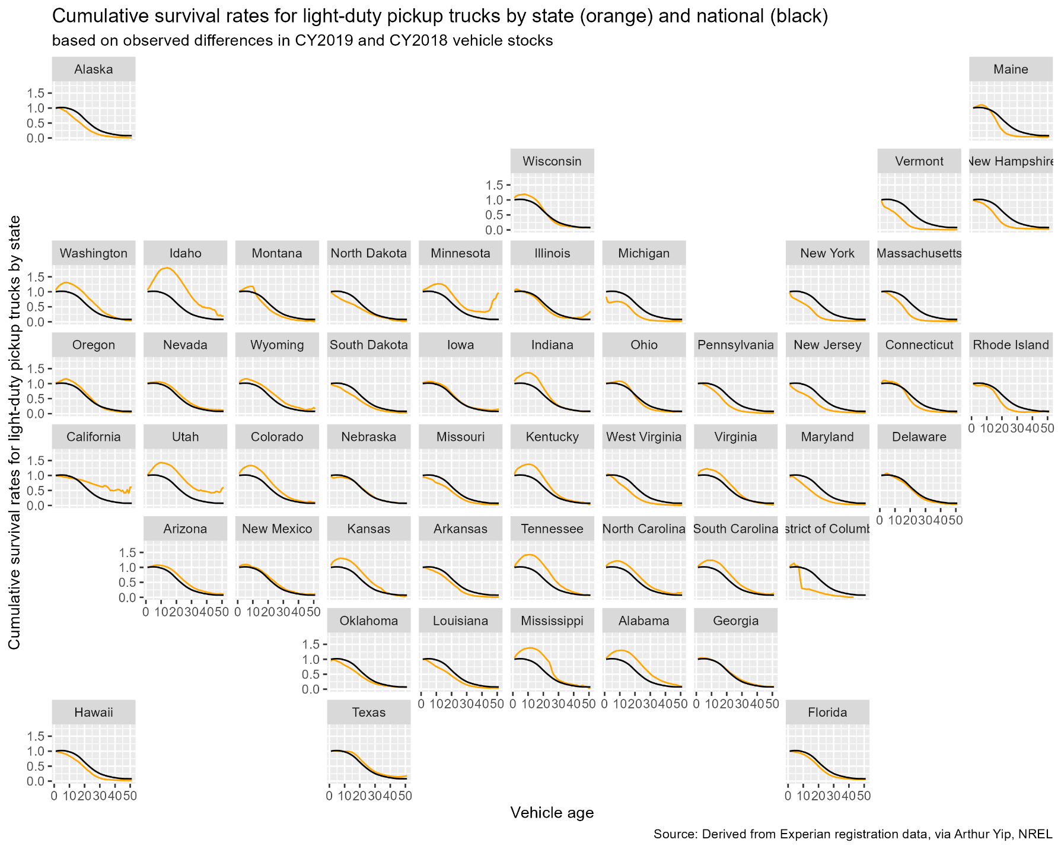
Appendix C. Data Sources for Exploratory Analysis of State Vehicle Survival Rates
Using Stepwise Regression

- Personal Income, GDP and Employment: Bureau of Economic Analysis (BEA), 2024. “BEA Data, GDP and Personal Income”, Table SASSummary State annual summary statistics, state personal income, GDP, consumer spending, price indexes and employment. Accessed at https://apps.bea.gov/itable/?ReqID=70&step=1#eyJhcHBpZCI6NzAsInN0ZXBzIjpbMSwyOSwyNSwzMV0sImRhdGEiOltbIlRhYmxlSWQiLCI2MDAiXSxbIk1ham9yX0FyZWEiLCIwIl1dfQ== . Real GDP in millions of chained 2017 dollars, personal income in millions of constant 2017 dollars, total employment in number of jobs. File: State_GDP_Pinc_Jobs_Pop Excel Workbook.
- Median Income: Bureau of Economic Analysis (BEA), 2024. Distribution of Personal Income, State Data and Documentation, Download detailed files for all states. Table “Personal Income Inequality Metrics by State”. Accessed at https://www.bea.gov/data/special-topics/distribution-of-personal-income .
- Land Area of State (for calculating population density): U.S. Census Bureau, State Area Measurements and Internal Point Coordinates 2010, accessed at https://www.census.gov/geographies/reference-files/2010/geo/state-area.html .
- Salt Use on Roads: Clear Roads, State Winter Maintenance and Data and Statistics, Additional Calculated Statistics – By Year”, 2018-2019. Note: data are missing for several states in the southern U.S. Accessed at https://www.clearroads.org/winter-maintenance-survey/ .
- Driving Age Population: U.S. Census Bureau, Annual Estimates of the Civilian Population by Single Year of Age and Sex for the United States and States: April 1, 2010 to July 1, 2019 File: 7/1/2019 State Characteristics Population Estimates, Table SC-EST2019-AGESEX-CIV.
- Urban and Rural Populations by State: U.S. Census Bureau, P2 DEC Demographic and Housing Characteristics, All States within the United States, Puerto Rico and Island Areas. Accessed at https://data.census.gov/table?q=P2&g=010XX00US,$0400000&d=DEC%20Demographic%20and%20Housing%20Characteristics .
- Interstate Traffic Congestion: TRIP, “America’s Interstate Highway System at 65: Meeting America’s Transportation Needs with a Reliable, Safe & Well-Maintained National Highway Network – June 2021”, https://tripnet.org/reports/americas-interstate-highway-system-at-65-june-2021/ .
- Highway Traffic Fatalities per 100,000 Vehicle Miles of Travel: U.S. Department of Transportation, Federal Highway Administration (FHWA), Highway Statistics 2018, Table F-10 (fatalities by state) and Table VM-2 (vehicle miles by state) and VM-4 (distribution of vehicle travel by state and vehicle type).
- Education: U.S. Census Bureau, American Community Survey, Educational Attainment by State 2017. Data file ACSSE2017EDUCATIONBYSTATE, created using the Census Bureau’s table creation tool at https://data.census.gov/table .
- Vehicle Miles per Light-Duty Vehicle: U.S. Department of Transportation, Federal Highway Administration, Highway Statistics 2018, Table MV-1 State Motor Vehicle Registrations, MV-9 Truck and Truck Tractor Registrations, VM-2 and VM-4.

This research was supported by Oak Ridge National Laboratory managed by UT-Battelle, LLC for the U.S. Department of Energy under contract No. DE-AC05-00OR22725, and by the National Renewable Energy Laboratory, operated by Alliance for Sustainable Energy, LLC for the U.S. Department of Energy under contract No. DE-AC36-08GO28308. The content of this report reflects the views of the authors and does not necessarily represent the views of the University of Tennessee, Oak Ridge National Laboratory, the National Renewable Energy Laboratory, or the U.S. Department of Energy.
Market research on the average lifetime of vehicles by state can be found on the internet (e.g., Junk Car Reaper, 2024).
A household can also dispose of vehicles by donating a vehicle or giving a vehicle to a family member outside of the household. These options could lead to state-to-state vehicle migration if the entity receiving the donated vehicle or the recipient family member were located in a different state.
Here, vehicle type j includes the age of the vehicle.
According to data from respondents sampled during Q1 2024 in the Consumer Expenditure Survey, for respondents with household income of $100,000 or more per year, 43 percent of vehicles purchased in 2023 were 2023 or 2024 model year vehicles. For respondents with household income of less than $100,000 per year, only 28 percent of vehicles purchased in 2023 were 2023 or 2024 model year vehicles.
dqadp0=∂qa∂p0+i∂qa∂pi∂pi∂p0=∂qa∂p0poqa+i∂qa∂pipiqa∂pi∂p0p0pi
The VINs themselves were not included in the data purchased by NREL and thus not available to this study.
The complete set of state graphs are in Appendix B.
Market research has addressed average vehicle lifetimes at the state level (Junk Car Reaper, 2024), and international trade in used vehicles from country to country has received serious attention in recent decades (e.g., Nieuwenhuis et al., 2007; Fuse et al., 2009; Chen et al., 2019; Ayetor et al., 2021).
A description of the data and sources is in Appendix C. In general, data for the explanatory variables are for the 2018 calendar year. All economic data are Bureau of Economic Analysis data and all population data are Census Bureau data for 2018. When 2018 data were not available, the closest year for which data were available was used, either 2017 or 2019. 2010 data were used for state areas.
The age of a vehicle in the available data is calculated as the calendar year minus the vehicle’s model year. Because vehicle model years do not begin on January 1 and end on December 31, but on varying dates, and because not all vehicles of a model year are sold in that model year, counts of 0 and 1-year-old vehicles do not produce meaningful estimates of survival rates and were excluded from the analysis.
We recognize that our method does not allow strict interpretation of significance levels as tests of hypotheses.
Because several model formulations were estimated before settling on the final formulation, significance levels should not be interpreted in the usual way as tests of null hypotheses but rather as indicators of the strength of the correlations between the independent variables and the dependent variable.
Showing all states, vehicle types and ages would be excessive, so we created a spreadsheet with three worksheets containing the results for each vehicle type. In each worksheet the curves for any state and year can be brought up by entering the state abbreviation (e.g., AL for Alabama) and year (e.g., 2021 for 2020 to 2021). Five states can be graphed at one time, as in the graphs below.
Such data exist, but the cost was prohibitive given the budget of our study.

